Ideation Phase
Empathize & Discover

Date | 25 September 2026
Team ID | SWTID-2026-3946
Project Name | AI BlogNest
Maximum Marks | 4 Marks

Empathy Map Canvas:
An empathy map is a simple, easy-to-digest visual that captures knowledge about a user’s behaviours and attitudes.

It is a useful tool to helps teams better understand their users.
Creating an effective solution requires understanding the true problem and the person who is experiencing it. The exercise of creating the map helps participants consider things from the user’s perspective along with his or her goals and challenges.
Example:
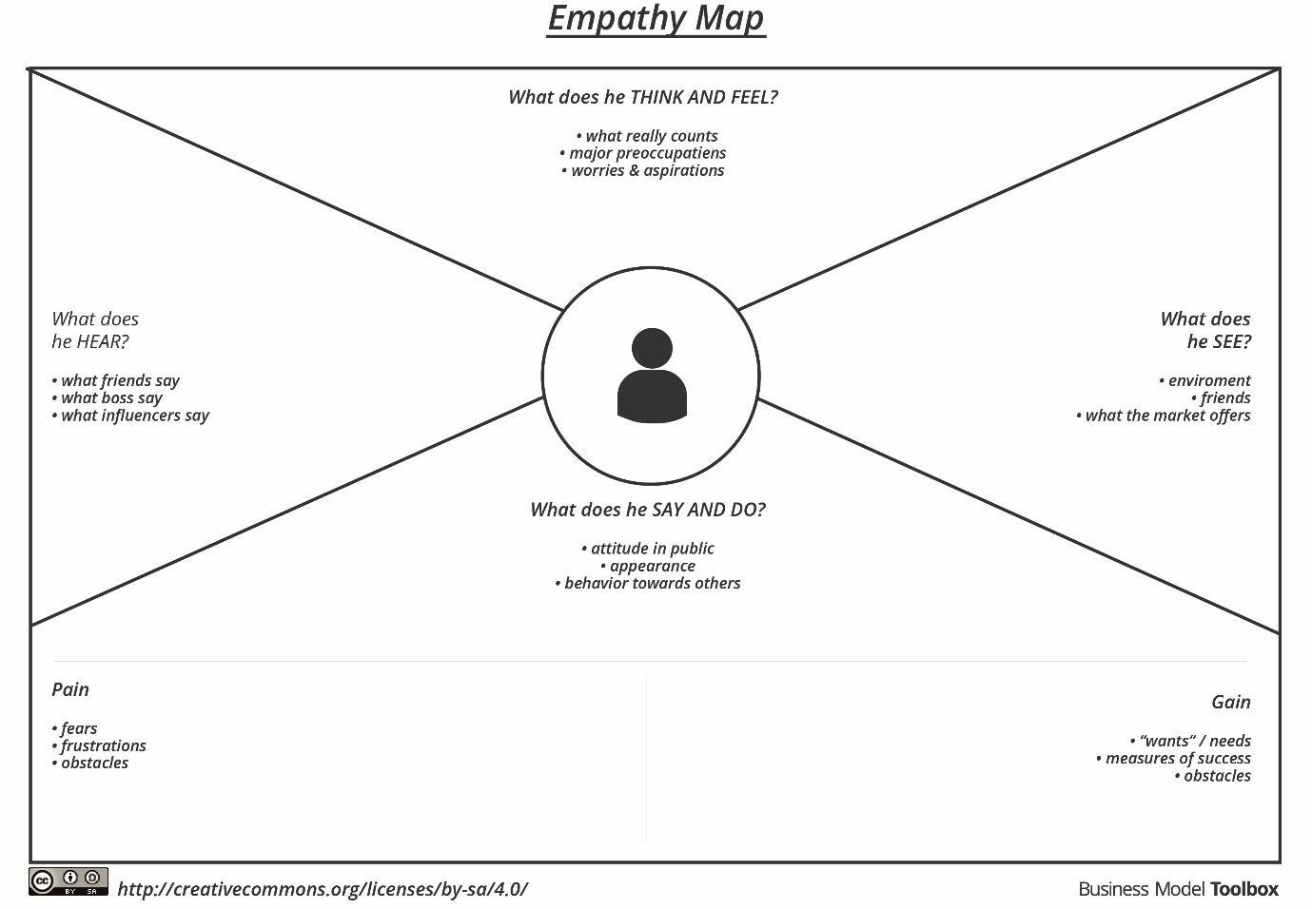

Reference: https://www.mural.co/templates/empathy-map-canvas

Example: Food Ordering & Delivery Application
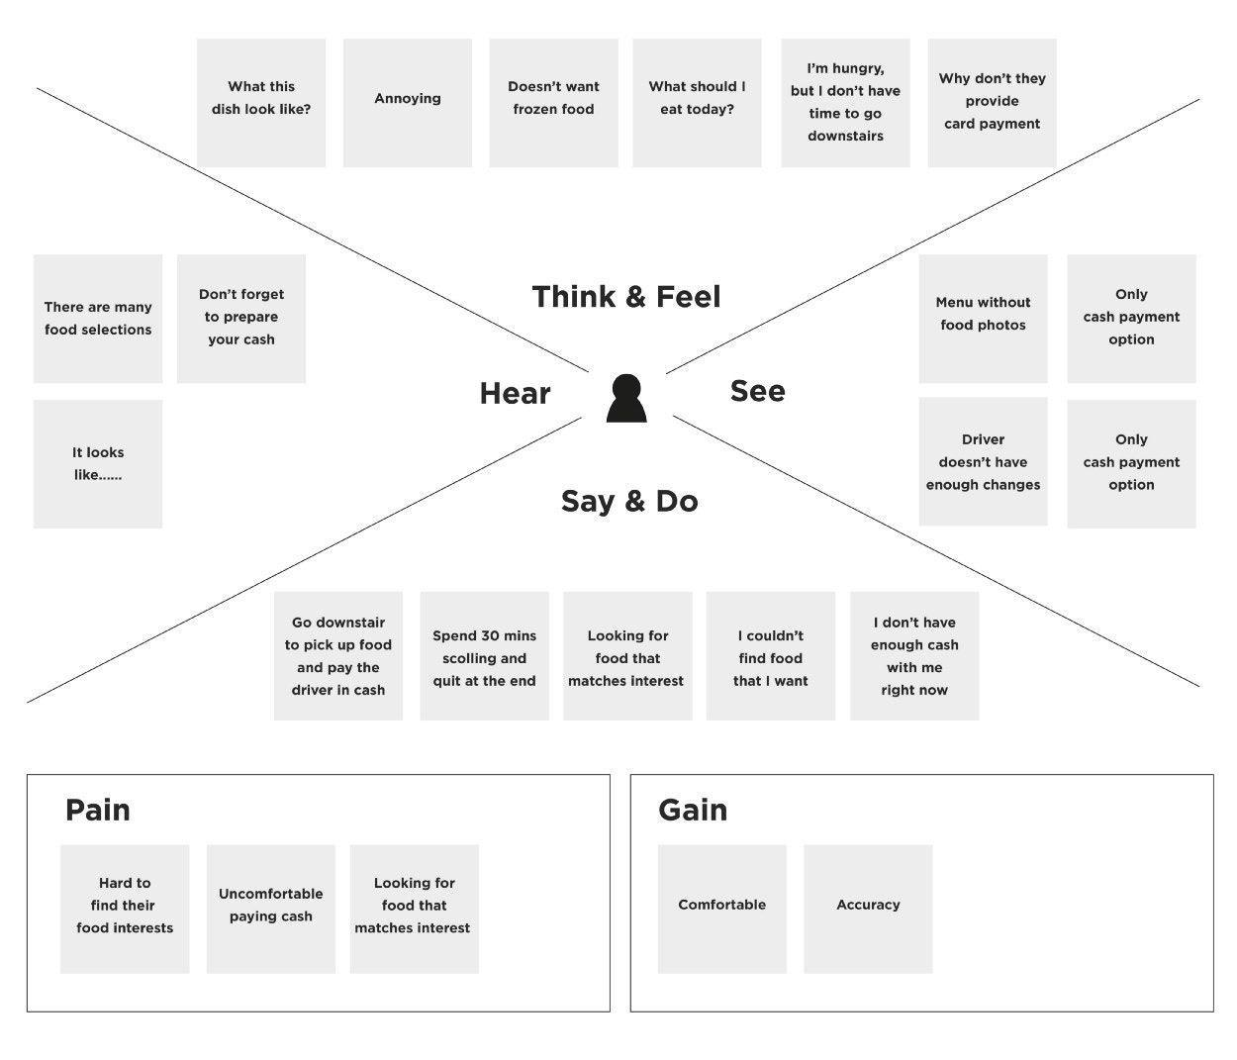
AI BlogNest – Empathy Map
Empathy Area | Project-specific user observations
Says | I want to create blogs easily; I want my data saved; I want secure login; I want AI help.
Thinks | I need a reliable API and predictable database storage.
Does | Registers, logs in, obtains a token, manages blogs and uses AI endpoints.
Feels | Wants the process to be simple, secure and quick.
Pains | Manual writing takes time; invalid requests or errors can interrupt work.
Gains | PostgreSQL storage, JWT authentication, CRUD APIs and AI assistance.
User Goals
• Create and manage blog content.
• Use AI to speed up content creation.
• Keep data in a database.
• Access protected features securely.
• Receive clear API responses.

